EXPT NO:6B | DATA VISUALIZATION USING POWER BI  (ADVANCED SALES ANALYTICS)

Aim:
To load the Ocean Pollution dataset into Power BI, transform the data, and visualize it to obtain meaningful insights.

Algorithm 1: IMPORTING DATA INTO POWER BI
Step 1
Open Power BI Desktop.
Step 2
Select:
Home → Get Data
Step 3
Choose Text/CSV.
Step 4
Browse and select:
Ocean_Pollution_Dataset.csv
Step 5
Click Load.
Step 6
Verify that the Ocean Pollution data has been imported correctly.

Algorithm 2: DATA TRANSFORMATION USING POWER QUERY
Step 1
Select Transform Data.
Step 2
Open Power Query Editor.
Step 3
Check for and remove duplicate records.
Step 4
Handle null/missing values in columns such as:
- Plastic_Waste_Tonnes
- Oil_Spill_Tonnes
- Marine_Debris_Tonnes
- Water_Pollution_Index
- Microplastic_Level_mg_L
Step 5
Rename columns if required and ensure that text columns such as Ocean and Country are properly formatted.
Step 6
Apply the changes and select Close & Apply.

Algorithm 3: ADVANCED TRANSFORMATIONS & DATA FORMATTING
Step 1
Select the Year column and ensure that its data type is set to Whole Number.
Step 2
Select Add Column → Custom Column.
Step 3
Create a new column named:
Total_Pollution
Step 4
Enter the Power Query M formula:
[Plastic_Waste_Tonnes] +
[Oil_Spill_Tonnes] +
[Marine_Debris_Tonnes]
This calculates the combined pollution quantity for each record.
Step 5
Check the numerical pollution columns for incorrect negative values and filter or correct them if necessary.
Step 6
Click Close & Apply to load the transformed dataset into the Power BI model.

Algorithm 4: CREATING CALCULATED COLUMN (TOTAL POLLUTION)
Step 1
Navigate to Report View or Table View.
Step 2
Right-click the Ocean Pollution table and select New Column.
Step 3
Enter the following DAX formula:
Total Pollution =
[Plastic_Waste_Tonnes]
+ [Oil_Spill_Tonnes]
+ [Marine_Debris_Tonnes]
Step 4
Press Enter to validate and calculate the values.

Algorithm 5: DASHBOARD VISUALIZATION & REPORTING
Step 1
Select a Line Chart visualization and map:
- Year → X-axis
- Plastic_Waste_Tonnes → Y-axis
This shows the change in plastic waste over the years.
Step 2
Select a Bar/Column Chart and map:
- Ocean → X-axis
- Water_Pollution_Index → Y-axis
This compares the pollution index between oceans.
Step 3
Select a Donut Chart to show the distribution of Total Pollution by Ocean.
Step 4
Add Slicer visuals for:
- Ocean
- Year
- Country
This allows interactive filtering of the dashboard.
Step 5
Save the Power BI file as:
Ocean_Pollution_Analysis.pbix

Handle null values (replace blanks/nulls in columns like CustomerName and Discount)
Step 5
Rename columns & format text casing (e.g., Capitalize Region)
Step 6
Apply changes & Close

Output:

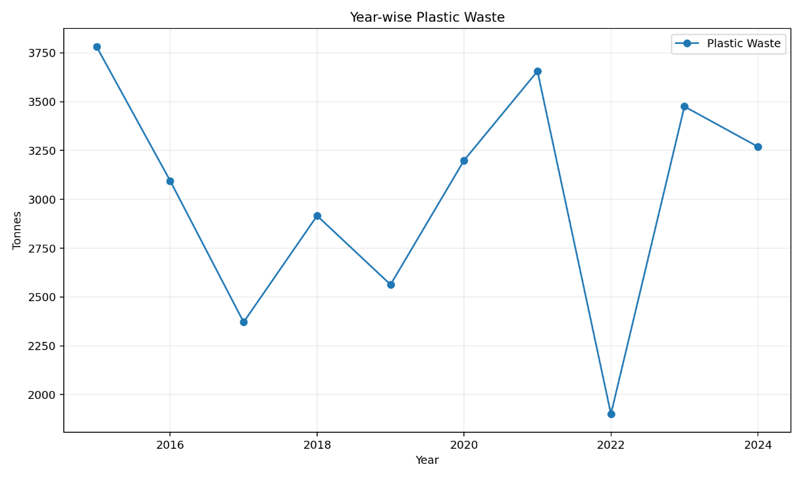

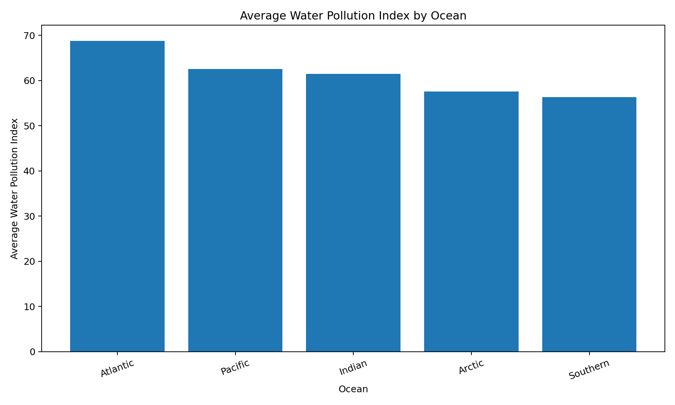
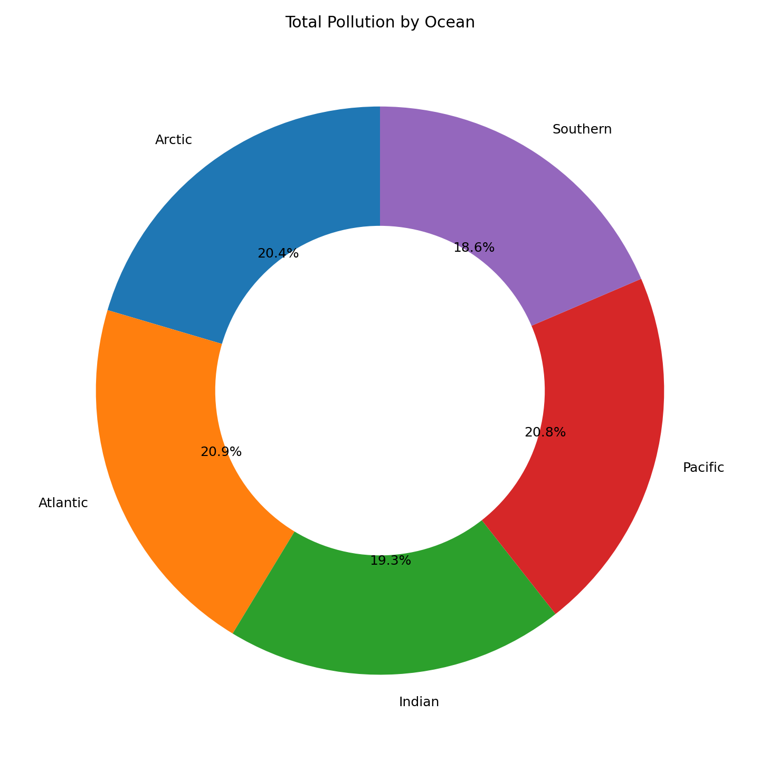

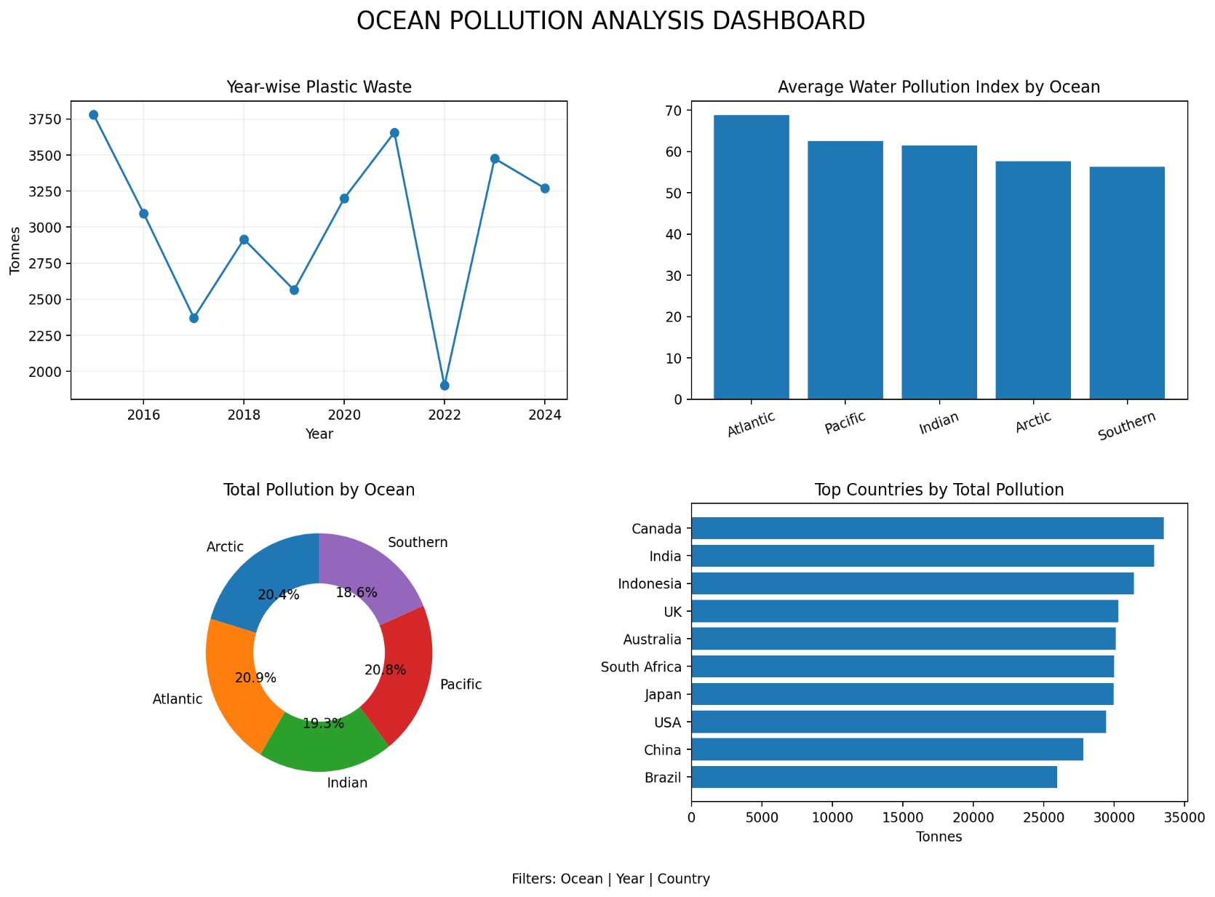

Result:

